***How have we studied Geometry using Art?***

*Let’s look back at what we’ve looked at…*

**Geometry in Nature**

Patterns of Transformations

**Geometry in Art & Design**

Dilation Transformation in String Art

**Geometry in Architecture**

Ancient Egyptian Pyramids

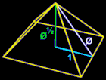 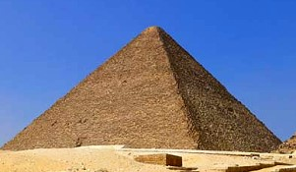

There is evidence that the design of the Great Pyramid of Egypt embodies foundations of mathematics and geometry:

* Phi, the Golden Ratio that appears throughout nature.
* Pi, the circumference of a circle in relation to its diameter.
* The Pythagorean Theorem – Credited to mathematician Pythagoras (about 570 – 495 BC), which can be expressed as a² + b² = c².

Geometry in Modern Architecture

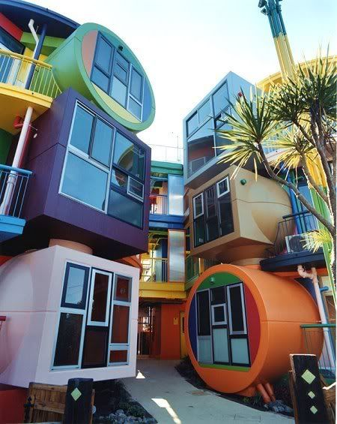 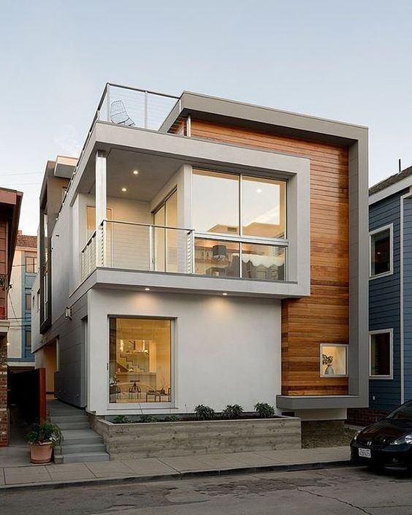

**Geometry in Architecture in NYC**

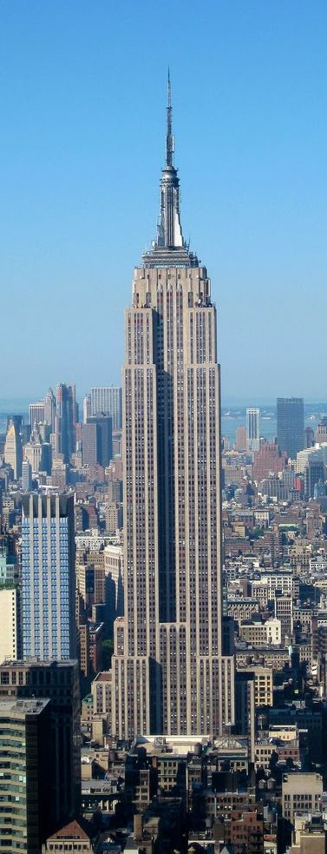 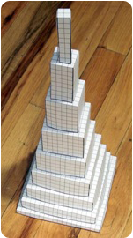 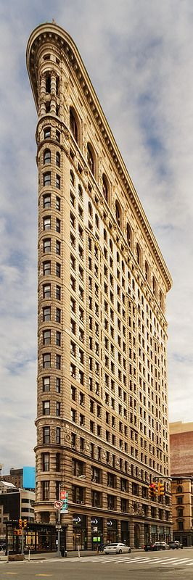

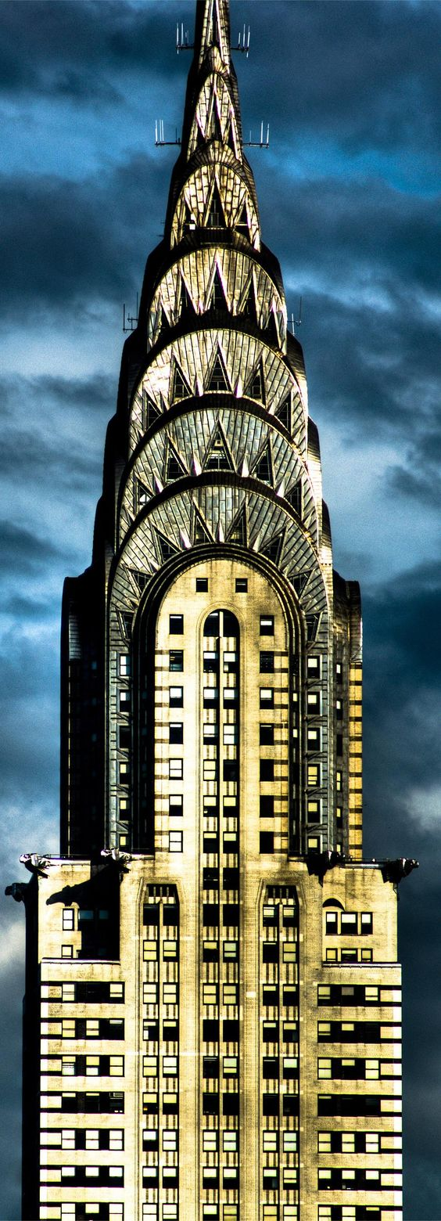 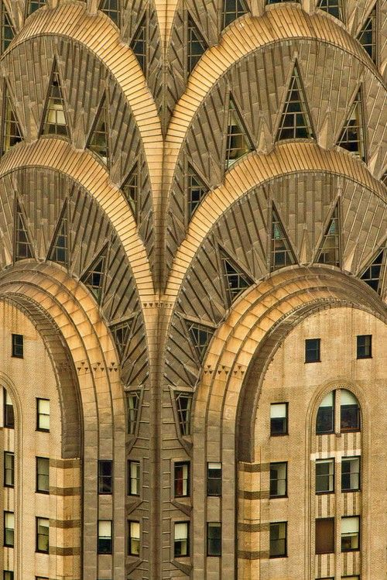 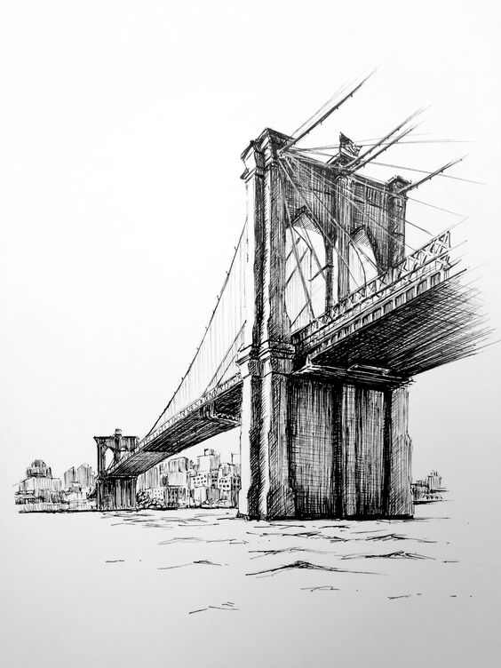

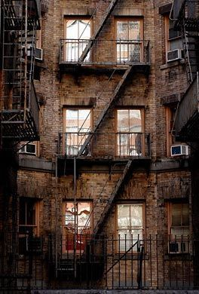 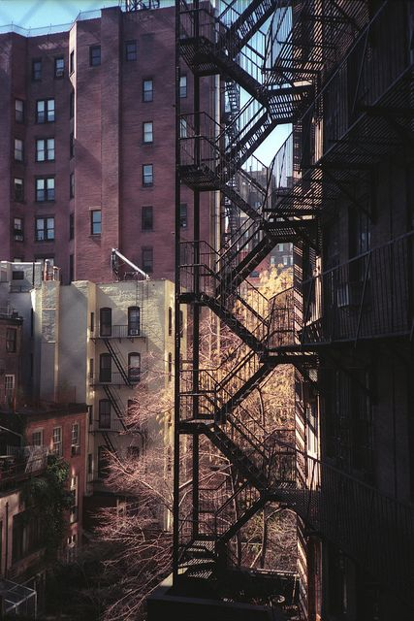

**Geometry in Art & Design in NYC**

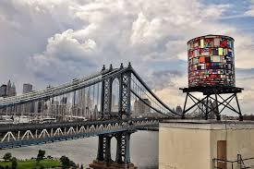 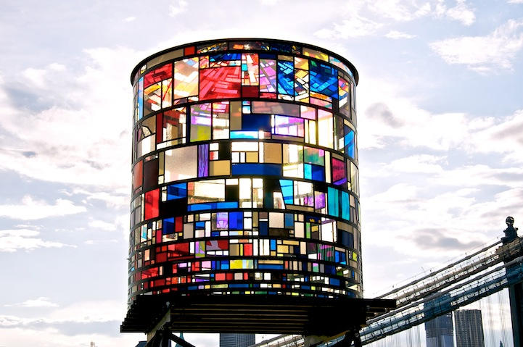

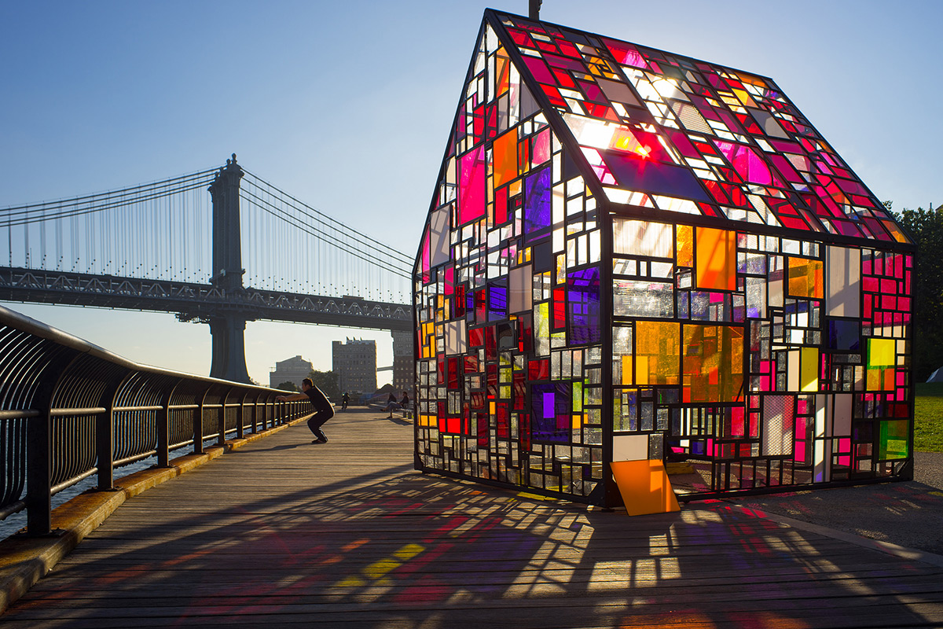

Brooklyn Artist: Tom Gruin

* Materials: 1,000 scraps of acrylic
* Location: Manhattan Bridge
* Theme/Aspects:
  + BBP’s dedication to sustainability; illuminates by the sun, solar-powered at night
  + Tribute to the iconic New York watertower (near the Manhattan bridge)

What’s next?

**Create your own building**

**using shapes**

